H.T No
Regulations:
A18

Sreenidhi Institute of Science and Technology
(An Autonomous Institution)
Code No: 7K406 Date: 12-Mar-2021 (AN)

B.Tech II-Year II- Semester External Examination, March/April - 2021 (Supplementary)
CONSTRUCTION ENGINEERING AND MANAGEMENT (CIVIL)

Time: 3 Hours Max.Marks:70

Note: a) No additional answer sheets will be provided.
b) All sub-parts of a question must be answered at one place only, otherwise it will not be valued.
c) Missing data can be assumed suitably.

ANSWER ANY 5 OUT OF 8 QUESTIONS. EACH QUESTION CARRIES 14 MARKS.

Bloom's Cognitive Levels of Learning (BCLL)

Remember | L1 | Apply | L3 | Evaluate | L5
Understand | L2 | Analyze | L4 | Create | L6

 |  |  | BCLL | CO(s) | Marks
1. | a) | Write the detailed procedure involved in critical path method and explain the other scheduling techniques. | L1 | CO1 | [7M]
 | b) | The following table gives the activity in construction projects.  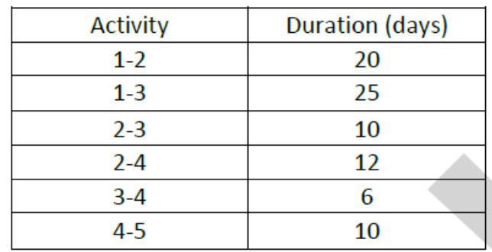  - Draw Network for project ii) Find the critical path | L5 | CO1 | [7M]
2. | a) | Explain in detail about different types of foundations and construction methods. | L2 | CO2 | [7M]
 | b) | State the advantages and disadvantages of Precast concrete construction. | L1 | CO2 | [7M]
3. | a) | Explain various types of earth moving equipment and their purposes. | L2 | CO3 | [7M]
 | b) | Explain in detail about Tower cranes and its advantages and disadvantages. | L6 | CO3 | [7M]
4. | a) | Explain in detail about Work Breakdown Structure. | L6 | CO4 | [7M]
 | b) | Discuss various inclusions in a Site Layout Plan. | L2 | CO4 | [7M]
5. | a) | Describe the causes of cost and time over run in construction and various controlling measures. | L1 | CO5 | [7M]
 | b) | Define lean construction and explain various principles of it. | L1 | CO5 | [7M]
6. | a) | Explain the details of Lump-sum contract and its suitability. | L6 | CO6 | [7M]
 | b) | State few conditions of contract. | L1 | CO6 | [7M]
7. | a) | Explain various phases of a construction project | L6 | CO1 | [7M]
 | b) | Differentiate the roles of Client and Contractor in construction projects | L4 | CO1 | [7M]
8. | a) | Summarize different types of deep foundations. | L6 | CO2 | [7M]
 | b) | Explain with a sketch the details of slab and beam formwork. | L2 | CO2 | [7M]

-- 00 -- 00 –

